3rd Grade Math
Standard | 3.0 Items
3.2A compose and decompose numbers up to 100,000 as a sum of so many ten thousands, so many thousands, so many hundreds, so many tens, and so many ones using objects, pictorial models, and numbers, including expanded notation as appropriate | 3.0a Using the base-ten blocks provided, write the following number in standard form.  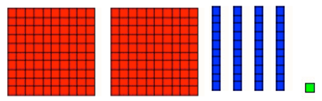  3.0b Show 254 in two different ways using the tools provided. (place value chips, base-ten blocks)  3.0c Write 30,000 + 4,000 + 800 + 2 in standard form.  3.0d Draw a picture to show the number 4,538.  3.0e Write the following number in expanded notation: 94,272.  3.0f Show 10 hundreds + 7 tens + 4 ones using the tools provided. (place value chips, base-ten blocks)
 | 2.0 Items
Write the following number in standard form.

(4 x 1,000) + (7 x 100) + (3 x 1) = ____________

Johnny wrote the expanded notation of 5,768 as

(5 x 10,000) + (7 x 100) + (6 x 10) + (8 x 1) =

Is he correct? Why or why not?

The sum of 7 ten thousands, 5 hundreds, and 8 tens can be expressed as what number in standard form?

What is the relationship between the hundreds place and the thousands place?

Draw a pictorial model of 678.

What number is represented by this pictorial model?
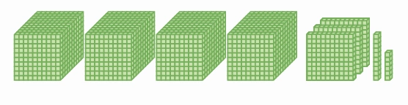

In the number 56,632, describe the relationship between the 6 in the hundreds place and the 6 in the thousands place.

The expression 700 + 200 + 40 + 70 represents the number 947. Is this statement accurate? Prove your answer as true or false.

Draw a pictorial representation that shows 1,063.

3rd Grade Math
Standard | 3.0 Items
3.2D compare and order whole numbers up to 100,000 and represent comparison using the symbols >, <, or = | 3.0 Use the table below to answer the following questions.  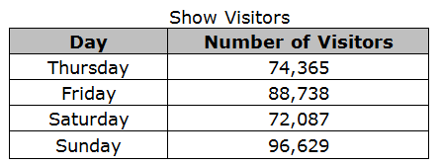  - Order all of the numbers from least to greatest.  - Which day has the greater value, Thursday or Saturday?  - Write a comparison statement using the “less than” symbol.
 | 2.0 Items
The list shows three clues about a number.
- The number is greater than 65,432.
- The number is less than 68,231.
- The number has a digit greater than 5 in the hundreds place.
Which of these could be the number described?

Use a comparison symbol (<, >, =) to compare these numbers.

458 _____ 485

4,691 _____ 11,834

13,985 _____ 13,985

79,241 _____ 79,513

Use these cards to make the greatest number possible.

4
7
0
5
2

Order these numbers from greatest to least.

14,378 18,241 17,398 18,830

__________ ___________ ___________ ____________

3rd Grade Math
Standard | 3.0 Items
3.4A solve with fluency one-step and two-step problems involving addition and subtraction within 1,000 using strategies based on place value, properties of operations, and the relationship between addition and subtraction | - Add these numbers. Show how you figured it out.  373 + 269 = ______  b. Subtract these numbers. Show how you figured it out.  524 - 186 = ______  c. Add these numbers. Show how you figured it out.  165 + 306 + 405 = ______  d. Find the answer to these numbers. Show how you figured it out.  837 - 229 + 45 = ______
 | 2.0 Items
Add these numbers.

85 + 54=

Subtract these numbers.

79 - 38=

Add these numbers.

63 + 58=

Subtract these numbers.

90 - 35=

Add these numbers.

205 + 457=

Subtract these numbers.

602 - 357=

Add and subtract these numbers.

512 + 396 - 72 =

Add and subtract these numbers.

721 - 314 + 118 =

Without solving, which equation do you know has the same sum as 314 - 176=___?
- 314 + 176 =___
- 176 - 314 = ___
- 176 + ___ = 314

Which equation would help you solve 248 + 474=___?
- ___- 474 = 248
- 474 - 248 = ___
- 248 - 474 = ___

Without solving, which equation do you know has the same sum as 278 + 156= ___?
- 278 - 156 =
- 156 + 278=
- 156 + ___ = 278

Round these numbers to the nearest 10.
45 _____
91 _____
57 _____
142 _____

Round these numbers to the nearest 100.
278 _____
819 _____
557 _____

Which equation is a good estimate for the sum of
521 + 176 =

- 500 + 100 = 600
- 500 + 200 = 700
- 600 + 200 = 800

Which equation is a good estimate for
612 - 186 =

- 600 - 100 = 500
- 600 - 200 = 400
- 700 - 200 = 500

Which set of compatible numbers gives the best estimate for
356 + 224

- 350 + 225 = 575
- 400 + 200 = 600
- 300 + 200 = 500

Which set of compatible numbers gives the best estimate for
883 - 243 =

- 900 - 200 = 700
- 900 - 300 = 600
- 900 - 250 = 650

Sara estimated 643 + 361 using the compatible numbers 650 + 350. Is this a good estimate? Why or why not?

Solve for the unknowns in the following equations:

42 + _____ = 97

____ + 210 = 436

185 - ____ = 132

_____ = 257 + 602

3rd Grade Math
Standard | 3.0 Items
3.5A represent one- and two-step problems involving addition and subtraction of whole numbers to 1,000 using pictorial models, number lines, and equations | - Which equation matches the number line shown.  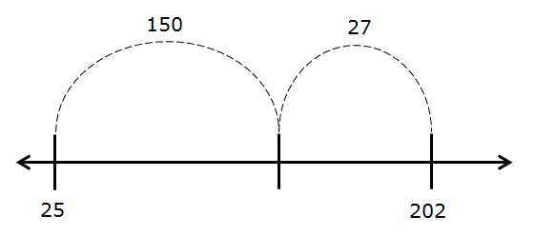  - 25 + 150 + 27 = ___  - 25 + 150 - 27 = ___  - 202 - 27 + 150 = ___  - 202 + 27 - 150 = ___  b. Which strip diagram matches the number line shown.  - Insert strip diagram  - Insert strip diagram  - Insert strip diagram  - Insert strip diagram  c. Draw a number line to represent this strip diagram.  .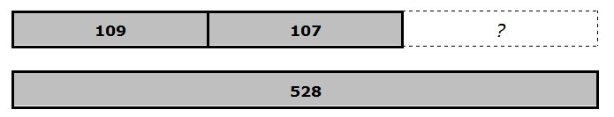  d. Write an equation to represent this strip diagram.  e. (Insert base ten model for 547 + 178)  Which equation represents the model?  - 557 + ___ = 178  - 547 + 178  - ___ + 178 = 547  - 557 + 178  f. Draw a number line to represent 473 + 63.  g. Write an equation to match the model.  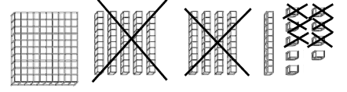  h. Show this model on a number line.
 | 2.0 Items
Write an addition and subtraction equation to match this number line.
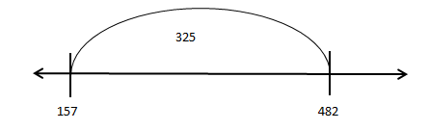

Write an equation to match the number line.
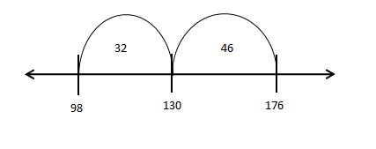

Draw a number line for this equation.

56 + ____ = 108

Draw a number line for this equation.

240 - 56 =

Draw a representation of this equation.

_____ + 32 = 85

Draw a representation of this equation.

245 + 312 = _______

Draw a representation of this equation.

600 - 245 =

Draw a number line for the following equation.

45 + 23 = _________

Draw a representation for this equation.

75 + 89 + ______ = 220

Draw a number line for the following expression.

123 + 53 - 75 = _______

Draw a representation for the following equation.

297 + 13 + 128 = ______

Write an equation for the strip diagram.
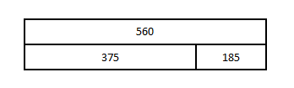

Write an equation for the strip diagram.

Write an equation for the strip diagram.
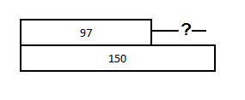

3rd Grade Math
Standard | 3.0 Items
3.5E represent real-world relationships using number pairs in a table and verbal descriptions | Can not assess 3.5E until after multiplication/division instruction.
 | 2.0 Items
Complete the table to show the relationship between Michelle’s age and Robert’s age.

Michelle’s Age | Robert’s Age
5 | 8
7
9 | 12
11 | 14
 | 17

Using the same table, describe the relationship between Michelle’s age and Robert’s age.

Describe the relationship between Robert’s age and Michelle’s age.

3rd Grade Math
Standard | 3.0 Items
3.8A summarize a data set with multiple categories using a frequency table, dot plot, pictograph, or bar graph with scaled intervals | The pictograph shows all the trees in the park.  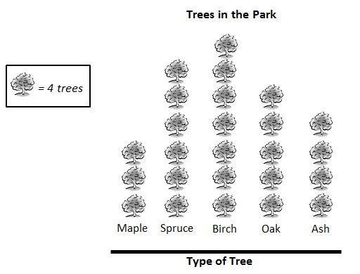  - Record the information in the pictograph in a frequency table.  - Use the grid to create and label a scaled bar graph representing the data in the picture graph above.  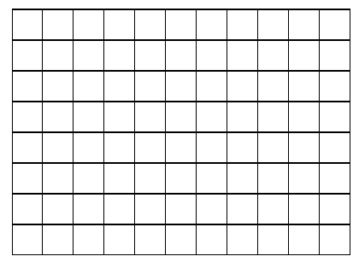  C. Write a statement about the spruce tree and the birch tree.
 | 2.0 Items
Create a frequency table using the data in the dot plot.
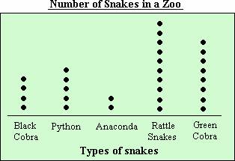

Create a dot plot to match the frequency table.
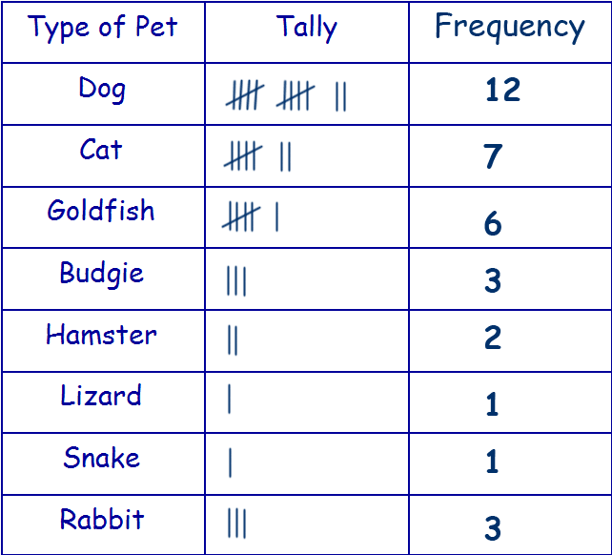

Use the graph to answer the following questions.
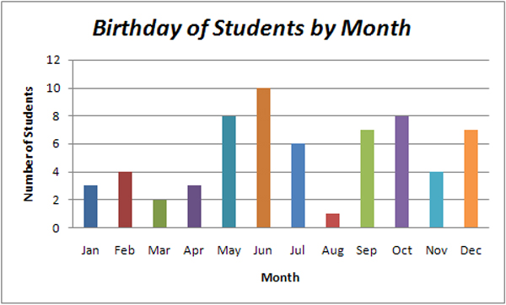

What is the interval in the graph? ______

What type of graph is this? _____________

Write 2 mathematical statements about the graph.

Use the graph to answer the following questions.
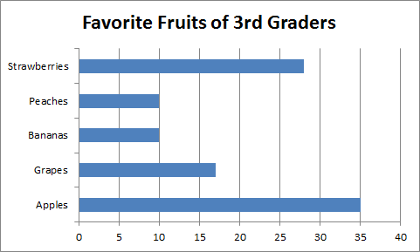

What is the interval of the graph? ______
Write 2 statements about the data.

Use the pictograph below to answer the following questions.
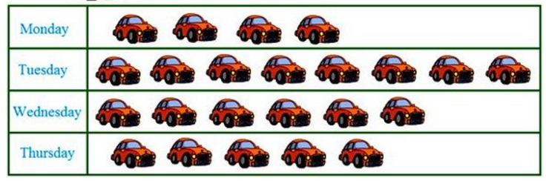
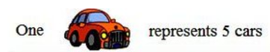
What could the title of this pictograph be?

Explain how the key helps you understand the pictograph.

Write a statement comparing 2 of the days in the graph above?

Write an equation representing the relationship of Monday and Tuesday.

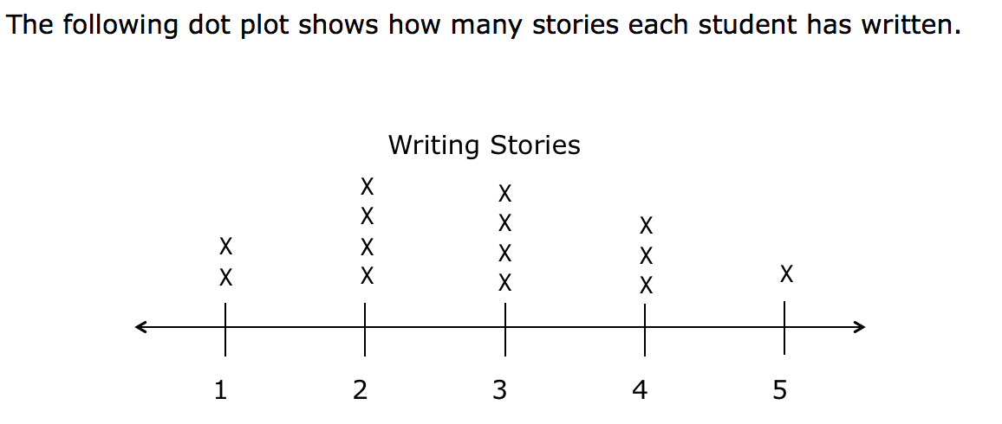
How many total stories were written?
How many students wrote fewer than 3 stories?

Standard | 3.0 Items
3.8B solve one and two step problems using categorical data with a frequency table, dot plot, pictograph, or bar graph with scaled intervals. | A.Using the bar graph below, how many more girls than boys like soccer?  B. Using the same graph, how many girls and boys like soccer, softball, and basketball?  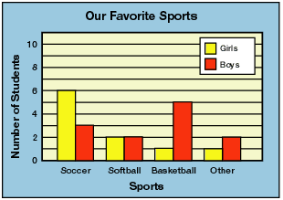  C. Using the dot plot below, what temperature has the greatest number of days at the same temperature?  D. Using the same dot plot, how many days is the temperature less than 9 degrees and greater than 16 degrees in all?  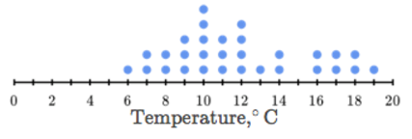
 | 2.0 Items
Use the pictograph below to answer the following questions.
How many more cars were sold on Tuesday than Thursday?
Write the equation and solve.

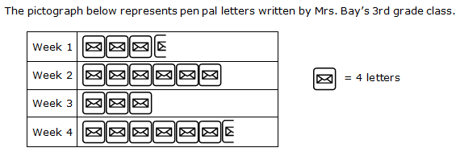
What does the represent?

How many letters were written in weeks 1 and 2 combined?

How many more letters were written in weeks 3 and 4 than in week 2?
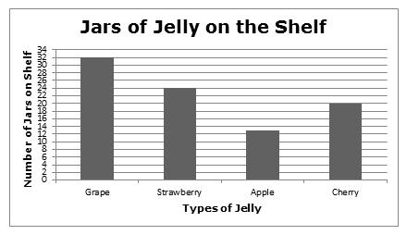A. How many fewer jars of strawberry jelly are there than grape jelly?

B. How many total jars of jelly are in the shelf?

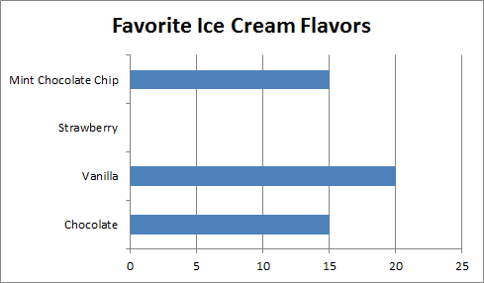

The bar for strawberry is missing from the graph. If 57 students were surveyed, how many students liked strawberry ice cream?

The following dot plot shows how many stories each student has written.
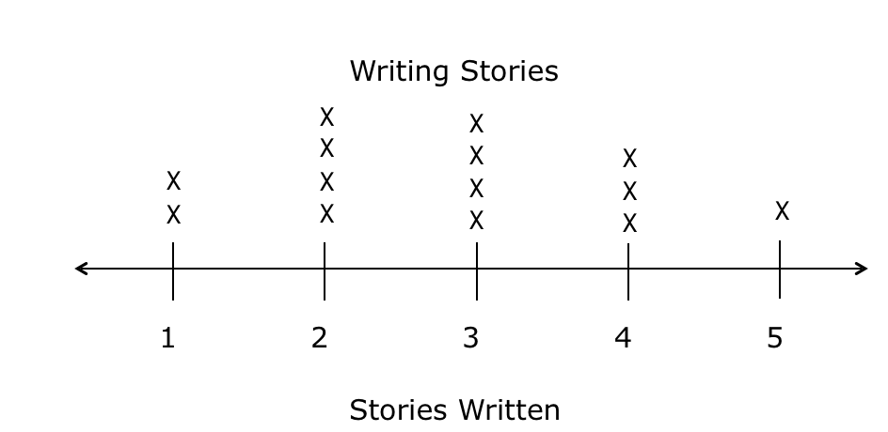

- How many students wrote 2 and 3 stories?
- How many more students wrote 1 and 2 stories than 3 stories?

The frequency table below shows the amount of money spent at a book store.

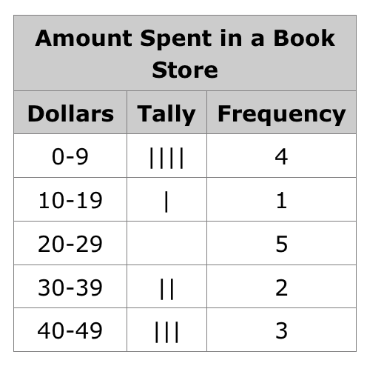
How many people spent more than $40?
How many people spent between $10 and $29?

